February 24, 2021

To whom it may concern,

I regret to inform you of my resignation, effective April 30, 2021. Due to a recent diagnosis of Pulmonary Tuberculosis based on my recently received medical examination. I have become aware that my illness will require extended treatment and recovery, and I am unsure of the result of my ability to perform the duties of my present position.

I appreciate your understanding. If there is anything I can do to help during the transition, please let me know.

Sincerely,

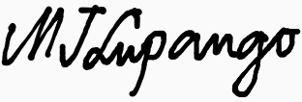

Mark Joseph Lupango  
mjldreamers@gmail.com  
09272561352